1. Scrum - Sub independent task
2. Burn Down charts - Work unit/Time Chart
   1. Applies for per team/ per sprint
3. Sprint Planning Meeting
   1. 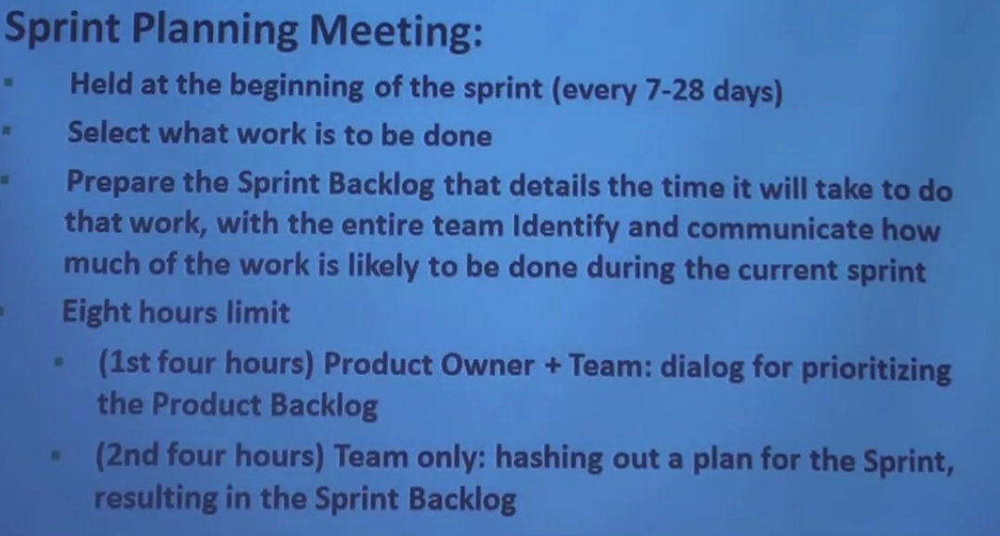
4. Sprint Review meeting
   1. 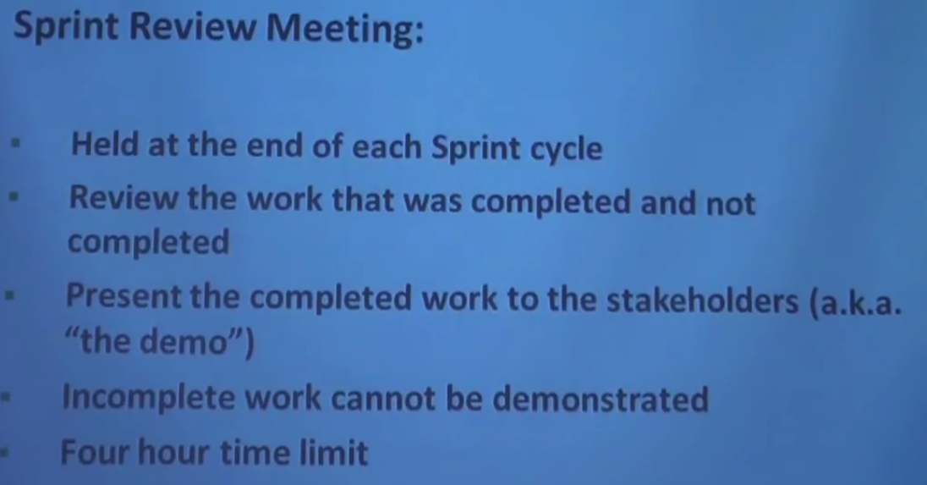
5. Sprint Retrospective
   1. 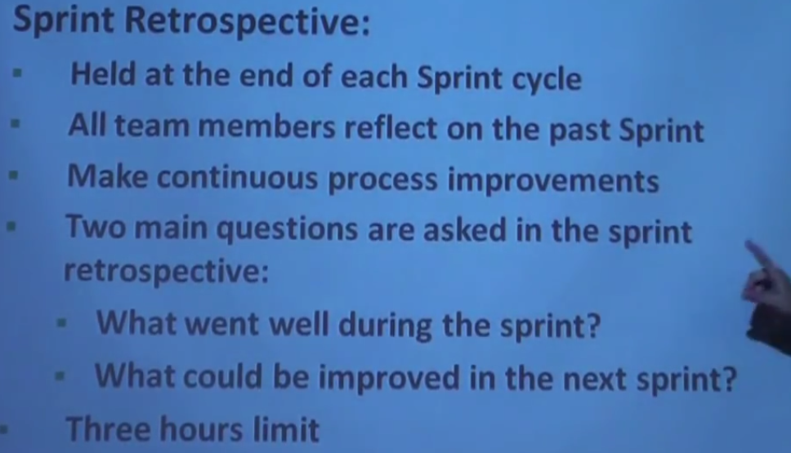
6. Daily Scrum/Stand up
   1. 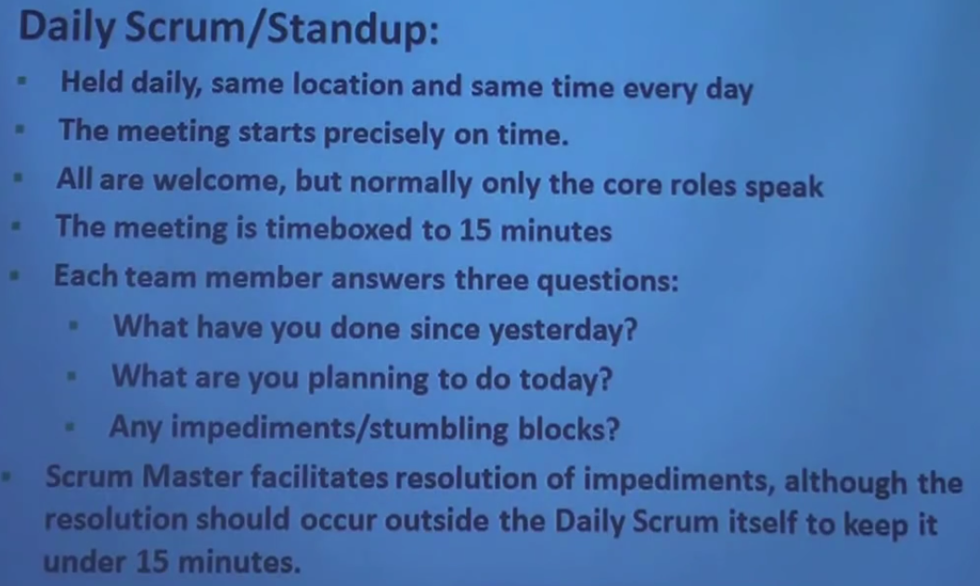
7. Definition of Done
   1. 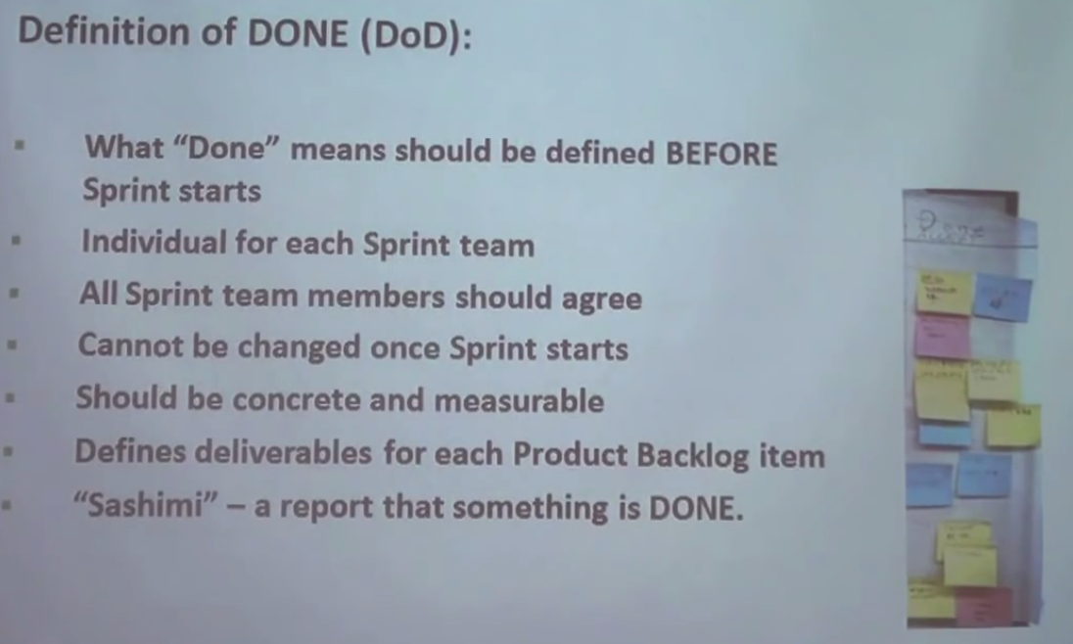
8. Sprint Result
   1. 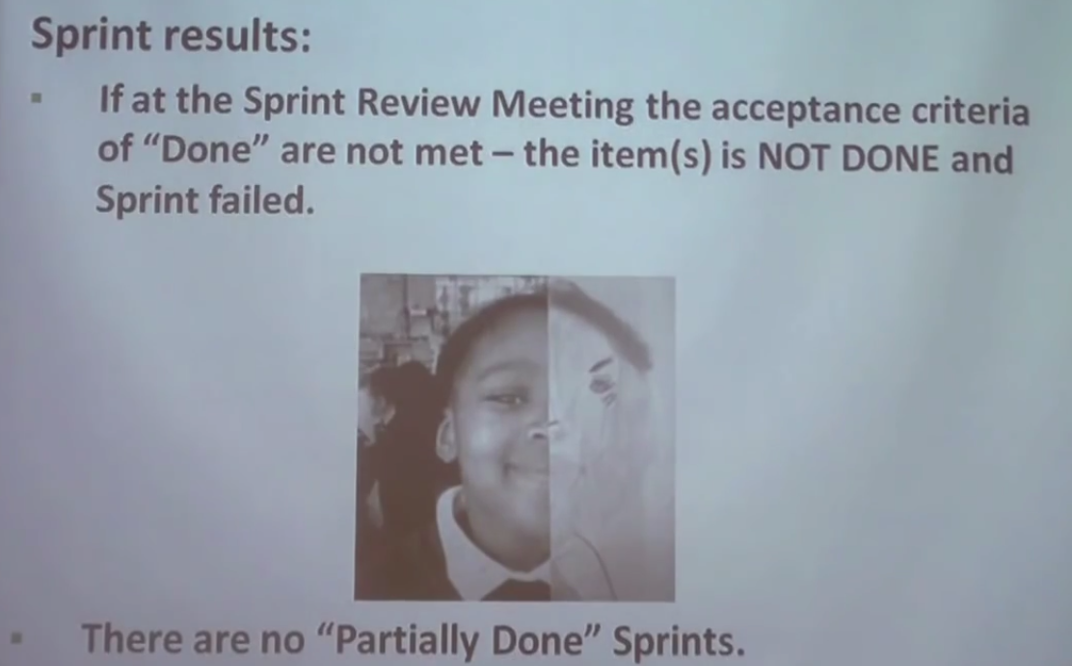
9. Time Box
10. Abnormally Termimated sprint
    1. 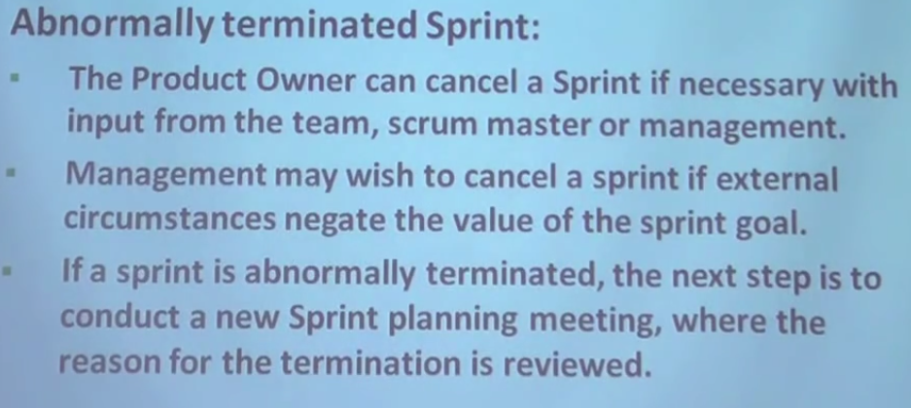
11. Inside a sprint
    1. 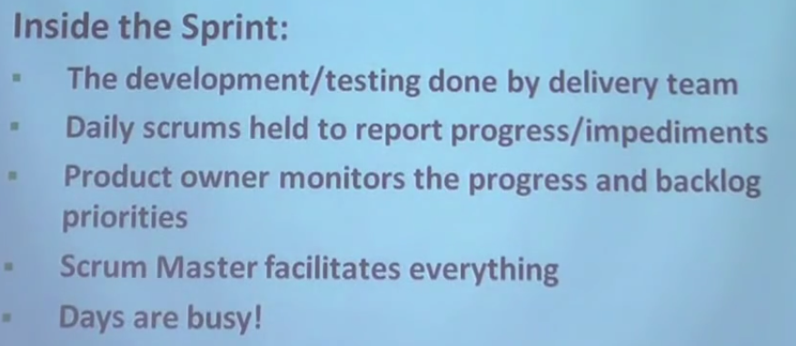
12. Sprint at glance
    1. 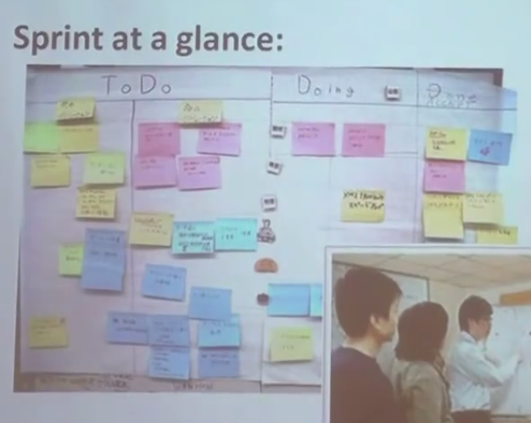
13. 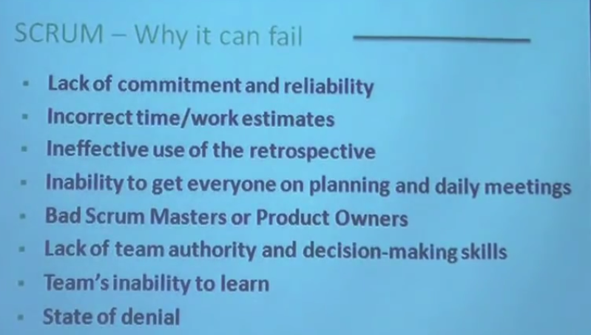
14. 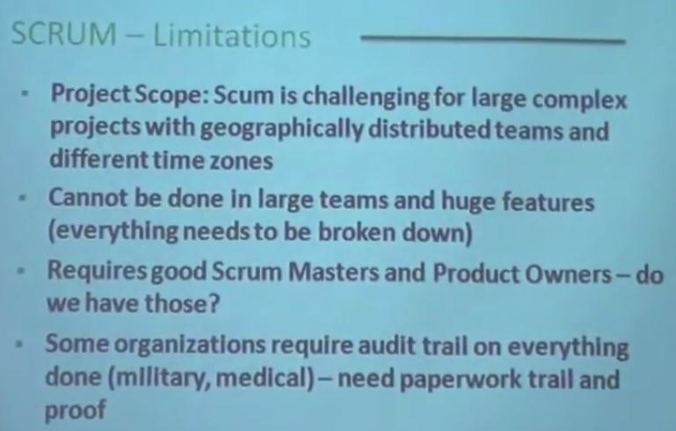
15. 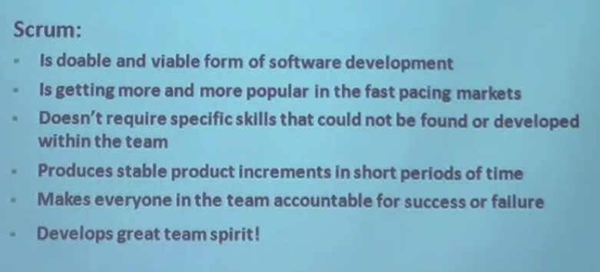
16. Scrum Master
    1. A Scrum Master is a team leader and facilitator who helps the team members to follow agile practices so that they can meet their commitments.
17. Product Owner
18. **Cross-functional Team**
19. **Point**
20. **Capacity**
21. **User Story**
22. **Relationship of User Stories and Tasks**
23. **Twelve Principles of Agile Manifesto**
    1. **Customer Satisfaction**
    2. **Welcome Change**
    3. **Deliver a Working Software**
    4. **Collaboration**
    5. **Motivation**
    6. **Face-to-face Conversation**
    7. **Measure the Progress as per the Working Software**
    8. **Maintain Constant Pace**
    9. **Monitoring**
    10. **Simplicity**
    11. **Self-organized Teams**
    12. **Review the Work Regularly**
24. **Iterative/incremental and Ready to Evolve**
25. **Face-to-face Communication**
26. **Feedback Loop**
27. **What is Daily Stand-up?**
28. **Why Stand-up is Important?**
29. **Who Attends a Stand-up?**
30. **User Story**
31. **Iteration**
32. **Release**
33. **Product Backlog**
34. **Release backlog**
35. **Velocity Calculation**
36. **Task Capacity**